Keep Active Hammersmith and Fulham Case for Support 2016-2017

**Introduction**

Keep Active helps older people who have lost some function due to illness or a fall to stay mobile and engage with their local community. It does this through working in partnership with the Central London Community Healthcare Rehabilitation Service (CRS) and has been funded this year through a number of small grants including City Bridge Trust, H&F Third Sector Investment Fund, H&F Fast Track Small Grant, The Woodroffe Benton Foundation and Sir Jules Thorn Charitable Trust.

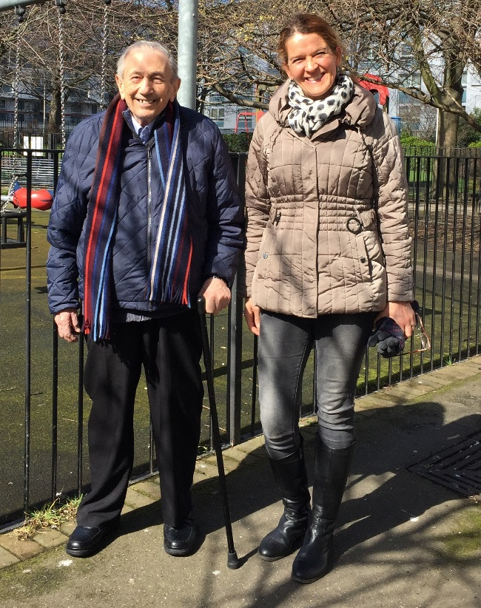Physiotherapists, Occupational Therapists & Rehab Assistants refer clients who they have worked with & are discharging but who could benefit from further support & encouragement with the mobility goal they have set for the client.

Keep Active’s trained volunteers have a handover session with the client and the physiotherapist where they go through the activity together. The volunteer meets with the older person up to 9 times to help them improve their confidence and independence with the activity.

**What volunteers do:**

Each case is dealt with on a case by case basis but activities volunteers have done with older people range from:

* accompanying them to an exercise class
* walking with them to a specific shop using their walking aid
* practising indoor strength and balance exercises
* Helping with a domestic task
* Practising using buses or trains in order to access the community once more.

**Outputs 2016-2017**

**140 clients** were referred to the Keep Active Service and have received ongoing support through the Keep Active 9 week recovery programme.

**64 active Keep Active volunteers** gave over **1,039** hours of support to clients.

**56 Volunteers** were trained in 12 training days. These training days took place in H&F and Westminster and included hands-on training from Physiotherapists and Occupational Therapists as well as BCH Induction nd BCH Keep Active delivered 12 extra training sessions to further the skills of their volunteers. These included Diabetes, Parkinson’s, Dementia Friends, and Blind Awareness and Mental Health awareness sessions.

**Outcomes**

Each year Keep Active evaluates approximately a third of the matches that have ended through volunteer phone calls. During 2016 Keep Active evaluated 43 patients 3 months post-discharge from the service. The results were as follows:

41 answered the questions (1 passed away and 1 didn’t speak English)

Out of the 41 who answered 2 had fallen and 1 ended up in A&E.

* **100%** of the patients found that Keep Active made a difference to them
* **75%** of the patients have continued their exercises or walking after discharge
* **66%** felt less isolated after discharge
* **95%** hadn’t fallen in the 3 months since discharge **\***

*The average age of a Keep Active client is 81 and nationally 50% of those over 80 will fall every year.

**Keep Active has built an excellent replicable model for prevention of falls in older people. This was recognized through awards and funding in Year 4.**

* Image result for rospa member logo email home safety member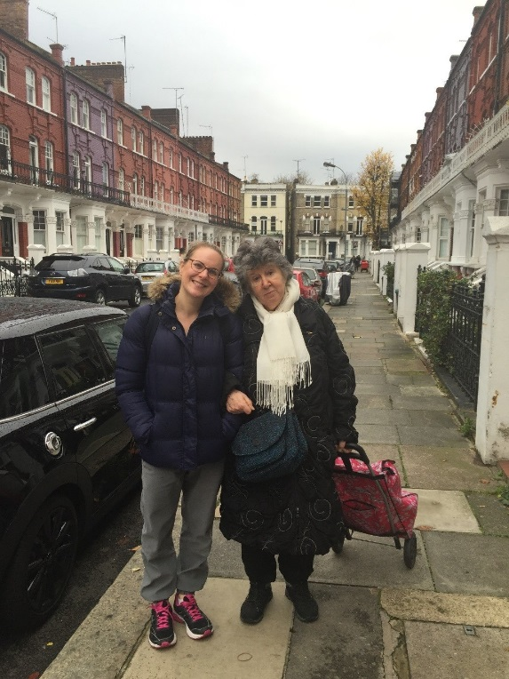*Keep Active was selected by ROSPA to be one of 10 projects nationally funded as part of their Stand Up Stay Up programme due to our excellent work in falls prevention.*
* *Keep Active received funding from the H&F’s 3rd Sector Investment funding for 18 months from December 2016*
* *Keep Active received funding from the Mayor of London ‘Get Moving fund’ to provide a 3 month Keep Active service to the Royal Borough of Kensington and Chelsea. Keep Active provided support to 21 RBKC clients from May to August 2016*

**Client / family quotes**

*“Anna has been such a big help to me. When she first came in to see me I was not doing well. I could not make it as far as I wanted to walk. Now after Anna has visited I can walk to the park and the church, we went to the park, sat, and talked. She was a very nice girl to have here”. Bernie (74) July 2016*

*“She came in to see me once a week and stayed for about an hour. She encouraged me to g for a walk even when I did not really want to get outside. I am glad in the 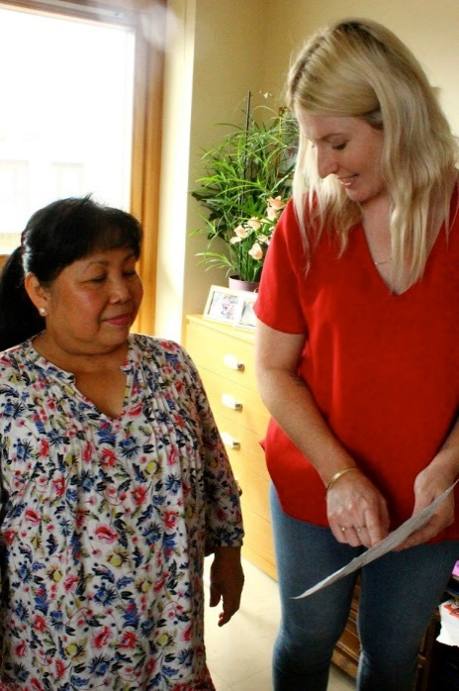end because you always feel better after a walk outdoors don’t you. She was such a good help. Say thank you to her again for me.” Brian (86) October 2016*

*“Keep Active has been remarkably helpful and I can’t think of any way you would improve it. It has made the exercises more enjoyable being able to do them with Alex here”.Sherban (92) March 2017*

*“It was so lovely having her come and walk with me. It is so kind that people are giving up their own time with their families to help me get outside. I hope that when Carol leaves me I am able to get out own my own. I do feel more confident outside now that I have practiced my walking a bit more with Carol.” Jill (94) June 2016*

**Physiotherapist Quotes**

“Keep Active has been an invaluable resource allowing our patients to continue to engage in their home exercises, outdoor mobility and socialisation, which is integral to the health and safety of an aged community. By providing ongoing support in the home, Keep Active are helping imbed the necessary routine of physical activity, which keeps our patients living safely at home. I fully support the need for their future funding and the loss of which would have significant consequences on the health of our aged community”. Natalie Stewart H&F Falls Lead Physiotherapist November 2016

“It has been always helpful to know that there is another service that we can refer our clients too. I have always found Keep Active volunteers very helpful, their friendly and positive approach and attitude made onward rehab for our clients easier and more pleasant. We need a service such Keep Active to allow our clients safe and positive rehab, outside of the NHS, where our funds and amounts of visits are also limited. I would like to express my concerns, at the same time hope that Keep Active will continue running and there will be new contract signed with Bishop Creighton House, what will only allow clients to receive onward support and care they need at home”. Marcin Kwiatkowski Band 5 Rotational Physiotherapist CRS H&F Falls Prevention Team October 2016