The City Bridge Trust
Date Sent: 24-Mar-16
Charity Registration Number: 1035628
GO: KMG

Monitoring & Evaluation Form
Working with Londoners (Grants of £10,000+)
Older Londoners

Name of Organisation in receipt of grant:  Bishop Creighton House | Grant Reference:  11230
Name & position of person completing form:  Joy Houghton-Brown | Contact Tel No/E-mail:  0207 385 9689 jhoughtonbrown@creightonhouse.org  .org.org
Original purpose of grant: £122,500 over three years (£40,250; £40,750; £41,500) for a full-time Volunteer Co-ordinator plus management and other costs of the Keep Active project.

1. | Has the grant payment for the year been used in full?  YES
2. | If not, please explain why this is the case and when it is expected to be fully used:
3. | Please provide the period of the grant awarded by the Trust. If the grant is/was for more than one year, please complete the relevant boxes below:
 |  | Year 1 |  | Year 2 |  | Year 3
FROM |  | month | year | month | year | month | year
 |  | 4 | 2013 | 4 | 2014 | 4 | 2015
TO |  | month | year | month | year | month | year
 |  | 3 | 2014 | 3 | 2015 | 3 | 2016
4. | If your grant includes staffing costs, please confirm the name(s) of the postholder(s) and their start date: Jelena Radusinovic 14/04/2014 (maternity leave wef 14 August 2015) Victoria Rodwell – maternity leave cover wef 27/07/15 - 24/2/2016. Charlotte Ness – maternity leave cover wef 15/2/2016
5. | Have you provided a copy of your most recent Annual Report, acknowledging support from the Trust, together with Audited Accounts covering the period during which the grant was used?  Annual Report: No  Audited Accounts: No
6. | If not, when will these be available?  Annual Report: October 2016  Audited Accounts: October 2016
7. | What were the key objectives of the work funded by the Trust?  1. To support isolated older and disabled people to get active and independent again after a fall or illness.  2. To recruit, train and support a team of volunteers to provide one-to-one encouragement and help in walking outside and exercising.  3. To work alongside staff in the Community Rehabilitation Service, complementing their professional care.  4. To create a working model for community health support, this could be replicated in other neighborhoods.

 |  | 8. | Have you received any training in monitoring and evaluation?  YES  If yes, who provided the training? Hammersmith and Fulham Community and Voluntary Sector Association (CAVSA): 19 April 2013
9. | Please tell us how you have met your objectives.  - Use the monitoring information you have been collecting to describe the project’s outputs* and outcomes* making it clear you know how you have achieved your outcomes.  1. Objective: To support isolated older and disabled people to get active and independent again after a fall or illness.  Outputs: 450 people in total (*150 people each year over 3 years) supported through a 9 week recovery programme by our volunteer and staff team. * Objective reduced to 100 people per year from year 2- see year2 report.  118 clients discharged from the Hammersmith & Fulham Community Rehabilitation Service (hereon referred to as CRS), have been referred to the Keep Active Service in year 3. They have received ongoing support through the Keep Active 9 week recovery programme. Keep Active volunteers have given at least 562 hours* of support to clients during this period.  * stats captured to date (some volunteers still visiting and hours have not been counted.  Outcome: Improved mobility, physical health and mental wellbeing for older people with a disability or poor health.  - Physiotherapists and Occupational Therapists identified patients that were due to be discharged, but who could benefit from more support with their goals. These clients were questioned before and after the volunteer support to assess the difference the Keep Active support had made and how it had impacted their health and confidence.  - In a follow-up questionnaire, 63% of clients reported feeling healthier and more confident with the programme/goal that CRS had set them, 16% maintained the benefits they gained with the exercise programme/goal that CRS had given them following the volunteer support and 21%* were unable to complete the Keep Active programme due to ill health.  *This reflects an older client age group (average age of 79) with many complex health issues  - Keep Active achieved these outcomes through close partnership working with CRS.  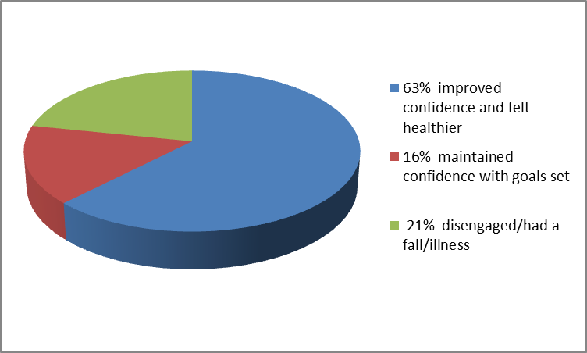  - 32% of clients were referred onto other support services within the community giving them further opportunities for social interaction and promoted mental wellbeing.
  - ‘Outputs’ are the quantifiable activities that your project has carried out in order to meet its objectives.
  - ‘Outcomes’ describe the effects or impact of your project and the difference you have made to those with whom you have worked.
  Your monitoring statistics and service user feed-back should help provide the information you need. If you are unsure about what information you should be collecting, please contact your Grants Officer.
There were 5 main goals worked on with the Keep Active clients during 2015-16:

- Exercises in the home
- Safe Use of Walking Aids
- Accessing the community
- Help with a domestic task
- Communication practise

The breakdown of goals is shown below:

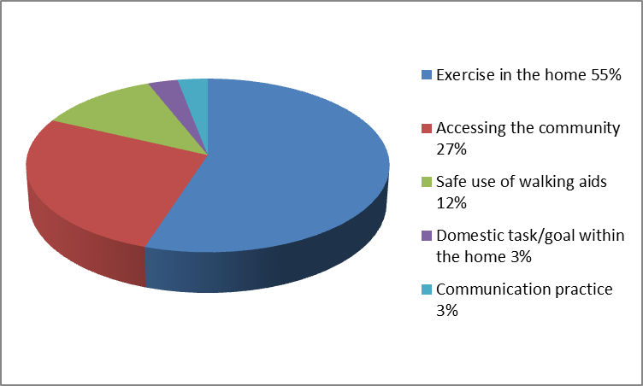

The mobility of clients is scored when they start with Keep Active and again when they finish the Keep Active program. 62% of those referred improved their mobility goal. 16% maintained their mobility goal and 22% had dis-engaged from Keep Active due to ill health.

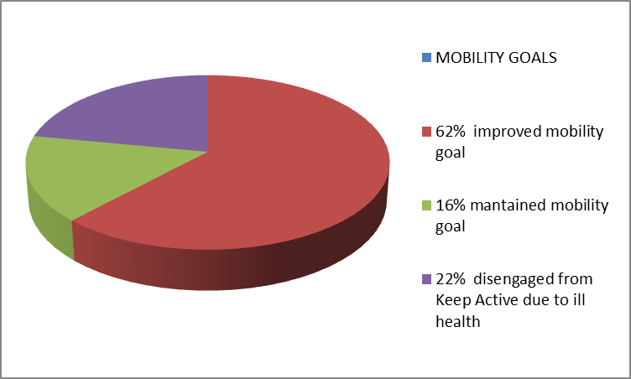

Please see also Appendices 1-6 for photos and Keep Active project Stories for year 3 2015-16
See also Appendix 7 for quotes from clients

2. Objective: To recruit, train and support a team of volunteers to provide one-to-one encouragement and help in walking outside and exercising.

Outputs: 150 volunteers recruited over three years; Bi-monthly training sessions provided from CRS; Bi-monthly volunteer meetings, quarterly steering group and ongoing support/supervision.

- In the third year we recruited 65 volunteers (between the ages of 17 to 73).
- 5 Bi-monthly training sessions have been provided by CRS and Keep Active and 65 Volunteers received high quality training by CRS staff (eg, Physiotherapist, Occupational Therapist and Community Rehab Assistant). 100% of the volunteers scored the training as ‘excellent’.
- In addition to this we provided 15 Bishop Creighton House Volunteer Induction training sessions which all volunteers attended so that they were familiar with our policies and procedures relating to good practice, personal safety and home visits. In addition to this we provided 7 additional trainings, these included:
Heartstart training, Dementia friends training, Nutritional Training ‘Eat Well to Live Well’, Stroke Awareness Training, Diabetes Training,Deaf/Blind training.
- Ongoing support/Supervision: support and supervision sessions were given to all volunteers by Keep Active staff during the process of monitoring the outcomes of our 9 week interventions. At these meetings volunteers talked through what went well, any difficulties and their future plans.
- Quarterly steering group: Keep Active staff met with CRS on a quarterly basis and 5 meetings have taken place. The next scheduled meeting will be in April 2016.
Outcome: Local people of all ages provided with a rewarding and meaningful volunteering experience, with training and support from physiotherapists.

- 65 Volunteers received high quality training by Keep Active staff as well as CRS staff (eg, Physiotherapist, Occupational Therapist and Community Rehab Assistant provide training).
- After interviews, volunteers were matched with clients. Volunteers were made aware that any queries or problems that immerged during their visits with the clients could be fed back to staff at Keep Active who in turn raised this with the physiotherapist or occupational therapist who had referred the client.
- Keep Active staff liaised between the volunteer and therapist ensuring that the volunteer felt that they could get support and advice from the Rehab team once they were doing the home visits on their own.
- Volunteers were flexible to visit evenings and week-ends as well.

See Appendix 7 for quotes from volunteers in year 3

3. Objective: To work alongside staff in the Community Rehabilitation Service, complementing their professional care.

Outputs: 450 ongoing cases (150 per year) from the community rehabilitation service discharged (into Keep Active)

In Year Three referrals came from Community Independence Reablement Service (CIS) and Community Rehabilitation Service (CRS)

In year Three a total of 118 patients (an increase of 67% on year 1) were discharged into the Keep Active Service. The breakdown of referrals was as follows:
CIS: 21
CRS: 97

There are matches still presently ongoing at the time of this report as shown from the chart below:

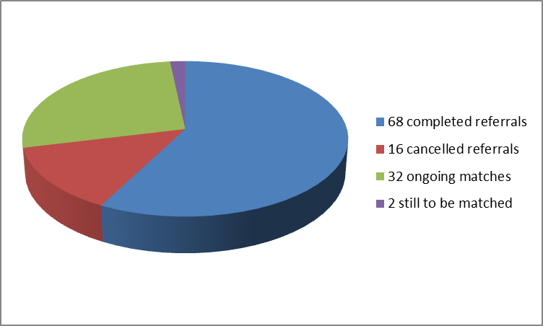
Outcome: Reduced pressure and more capacity to concentrate on acute cases for
the Community Rehab Service

The recent quote below demonstrates how Keep Active reduces the pressure on the Community Rehab Service and how much it is appreciated and supported by their staff:

11 January 2016
Quote from Natasha Booton , Clinical Lead for Falls and Bone Health
Central London Community Healthcare NHS Trust

‘’I would like commend the service that Keep Active in H&F has provided CLCH rehab clients over the last 3 years. The service has been run professionally and efficiently throughout and the Keep Active team have forged positive working relationships with all the key stakeholders in the numerous teams that make up the CLCH rehab services in H&F. Clinicians using the service have only had positive feedback to offer about working with Keep Active and report the reassurance it offers to them and their clients to know that there will be continuing support after discharge. All too often clinicians see the hard won gains made with their clients disappear as these often vulnerable and complex clients fail to get the support they need to continue to build their confidence and practise mobility, functional tasks and exercise. A referral to Keep Active also means that the client will automatically be considered for the telephone befriending service run out of BCH, which means one less referral for busy clinicians to make.

From a clinical lead perspective some of the other extremely positive outcomes have been reduced referrals back to rehab services following Keep Active intervention, suggesting that clients are being fully supported within the community and are being empowered to manage their long term health conditions independently. Other trends have been a reduction in falls and hospital admissions, which is not only great for the clients but also for the healthcare economy as a whole. Keep Active offers an extremely cost effective, holistic and patient centred service as well as offering volunteers an opportunity to gain experience in health and social care. It would be a significant loss to the clients and therapists in H&F if the service was discontinued and would represent a real backwards step after showing such positive outcomes in terms of client quality of life and hospital/injury prevention’’.

See also Appendix 7 for more Professsional comments in year 3

Outcome: Reduced hospital re-admissions following falls or illness.

• In your application you said you would meet the following outcomes of the Trust:

More over 75's living healthier and more active lives.

Your report should also describe how you met our outcome(s) and how you know you have achieved this.

• Where appropriate, we would like to see a summary of your monitoring statistics and feedback from those with whom you have worked.

How we met your outcome: More over 75's living healthier and more active lives:

The Keep Active project has enabled 118 older people (average age of Keep Active clients in Year 3 was 79) discharged from CRS and CIS to receive over 562 hours of continued support with their goals: indoor exercises, mobility, accessing the community, domestic tasks and communication practice.

How we know we have achieved this:
- All clients were questioned before and after the volunteer support to access the difference the volunteer support had made and how it had impacted their health and confidence. There was an increase in health and confidence in 63% of the clients.
- At the beginning of the volunteer support, the physiotherapists and occupational therapists graded the client’s ability with the goal set according to a rating from -2 to +2. At the end of the session the clients were graded again and an increase in this score was seen in 62% of cases.
- Keep Active achieved these outcomes through close partnership working with CRS and CIS. Physiotherapists and occupational therapists identified patients due to be discharged, but who they felt could benefit from more support with their goals.
- 32% of clients were referred onto other support services within their community which gave them further opportunities for social interaction and promoted mental wellbeing.

See Appendix 7 for quotes from clients, volunteers and professionals with whom we have worked.

4. Objective: To create a working model for community support which can be replicated in other neighbourhoods

Outputs: Project piloted in Hammersmith and Fulham, providing a replicable model and case studies for providers in other boroughs.

Outcomes: Replicable model for community-based mobility support created and tested; Positive outcomes of project benefit older people across large geographical area

The Keep Active project has been successfully piloted in Hammersmith and Fulham as can be seen from this report. Keep Active as a model has been commissioned by Public Health to work in Westminster for 3 years from January 2016.

See Appendix 8 for Falls prevention Service pathway with new falls projects (including Keep Active) Westminster

We also have demand for our service from Kensington & Chelsea. We are talking to Commissioners and actively seeking funding opportunities to begin Keep Active in that borough. See Quote below for example:

“Having moved from H&F to the falls/CRT team in K&C I really see where the service could be used, there are lots of clients who can’t attend groups or don’t want to who would really benefit from the 1-1 service that Keep Active provides, it’s such a confidence builder for clients. Hopefully it gets rolled out here in the future”. Clare Farrell, K&C Falls team August 2015
We have recently (March 2016) obtained £7,000 short term funding from the GLA (General London Authority) which will see Keep Active trialled in Kensington and Chelsea. This funding will be used during the period April to July 2016.

10 | Did the objectives change? NO
11 | If yes, please describe below:
12 | What have you learnt from this piece of work?  What went particularly well/was especially effective?  - High number of referrals – 118 compared to 71 in year 1 (an increase in 67%)  - Public Health have awarded Keep Active funding to expand the project to Westminster borough for 3 years from January 2016  The fact that the Keep Active project is managed by Bishop Creighton House (BCH) has bought many advantages to the project making it work well and be effective.  - As known from Year 1 BCH has a well-established long term befriending service for isolated older people called ‘Homeline’. Homeline and Keep Active continue to work closely together on volunteer recruitment delivering Volunteer Induction Training Sessions to volunteers together- thus saving on staff costs.  - The Keep Active project also sits alongside Beating Isolation (a partnership between Mind, BCH and Fulham Good Neighbours providing all-age befriending).  - If Keep Active staff identify further support needs in their clients they can be referred on to Homeline or Beating Isolation, ensuring they have a long-term continuation of support after Keep Active sessions come to a close. 32% of clients were referred on for further befriending this year.  Are any aspects of your work replicable?  YES – All aspects
Please give details below.

The outcome for Objective 4 includes Keep Active being a ‘Replicable model for community-based mobility support’.

Keep Active has been commissioned by Public Health to work in Westminster for 3 years from January 2016. We also have demand for our service from Kensington & Chelsea Borough and we have just received £7,000 to trail the work in K&C for 4 months from April- July 2016.

See Question 9 Objective 4 outcomes for further details

- What did not go as well/was challenging?

Being a partnership project with the Community Rehab Service has been very beneficial, helpful and essential but also challenging at times as they have faced reorganisation and changes of staff due to use of locums instead of permanent staff.
We have also had staff changes ourselves due to maternity leave and the ending of 3 year funding.

13 | Has the grant contributed to your organisation’s development? If so, please describe, including any benefits it has brought to your organisation beyond financial ones.  The City Bridge grant has enabled BCH to work in close partnership with the NHS (Central London Community Healthcare) and our partners in the NHS are seeing the benefits of working with the voluntary sector – see Appendix 7 and comments below for example:  “I think Keep Active is an essential service for H&F as a continuation of physical activity once a client has been discharged from an NHS community rehabilitation team. We feel reassured that clients are in good hands to continue working on their goals more independently - Keep Active volunteers have a collaborative approach in establishing a client’s needs and wants by effectively communicating with therapists and clients, and tailoring their input accordingly.”  18/1/2016 Eleanor Eastham, Band 5 Rotational Physiotherapist  “The Keep Active service has been invaluable to us in the CRS team! It has been really helpful in providing further support to clients who need input over a longer period of time than what we are able to provide within our service. If Keep Active ceases to continue, it will certainly impact on our clients who really need this input to build confidence with outdoor mobility or who need a few more sessions to practise their home exercise programme to get to a point where they are able to continue to do it independently”.  19/1/2016 Tara Mills , Community physiotherapist  This grant has helped our projects work together more, for instance with Homeline to refer clients on) and also recruiting and training volunteers together. Some volunteers stay with their client long term and actually both of them become long term members of the Homeline service so that client and volunteer can be supported together.

14. |  | Have there been any substantial changes in your organisation since the grant was made (e.g. key personnel, management committee members, funding, premises)? If so, please give details:  Jelena Radusinovic, the Keep Active Coordinator left on maternity leave on 14 August 2015. Victoria Rodwell was appointed as maternity cover for Keep Active on 27th July 2015 (extra days to allow for handover). Victoria left on 24th February 2016 to work in Wales and Charlotte Ness has taken over the Keep Active Coordinator role from 15th February 2016.
15. |  | What further steps has your organisation taken to reduce its carbon emissions?  - The Keep Active manager has used a bicycle when travelling around the borough. This has reduced costs and carbon emissions. The Keep Active Coordinator has walked or used buses to travel around the borough.  - BCH have rented a second hand photocopier and has been actively recycling print cartridges and paper. Recycling bins are used throughout our community centre and offices.  - 99% of all Keep Active staff and volunteers have used public transport (eg, buses and tubes) or walked with this project.
16. |  | Is this project or activity to continue after the Trust’s funding has come to an end?  YES though on a temporary basis until longer term funding is established.
17. |  | If so, how will it be funded?  - We have been commissioned by Public Health to deliver Keep Active in Westminster. This project began in January 2016.  - Funding for H&F is short term at present. We have 3 months funding (£10,000) from City Bridge and we have (£8,000) promised from the Fast Track Small Grant scheme with H&F Council. We have also won £7,000 from GLA to provide Keep Active over 3 boroughs (K&C, H&F and Westminster for 4 months from April to July 2016.  - Together these funds will keep the service going in its present form until at least September 2016. We have applied to other trusts and are hoping to apply for longer term funding when services are commissioned through H&F Council 3rd Sector Investment Funding later this year.
18.  118 |  | How many people have benefitted from this grant in this year?
19. |  | Has this grant had an effect on your other fundraising results?  Yes over the 3 years we have seen that other trusts and organisations are willing to invest also in this project. See Year 2 report and answers to question 17 and 20.
20. |  | If it has been helpful, please give details:  - Public Health have awarded Keep Active funding to expand the project to Westminster borough for 3 years from January 2016  - This is exactly what we set out to accomplish in building Keep Active as a replicable model that could be developed elsewhere.  - We continue to work on seeing Keep Active expanded to other areas as funding allows.  - The secure 3 year funding from City Bridge allowed this project to flourish and prove itself to be a simple and replicable model that is both sustainable and effective. Thank you.
21. What are your key activities for the work funded by the Trust over the coming Year?

N/A funding ends 31 March 2016
22. Are there any factors envisaged, internal or external that would affect the future viability of the project over the coming year?

Lack of funding
Loss of key staff at BCH
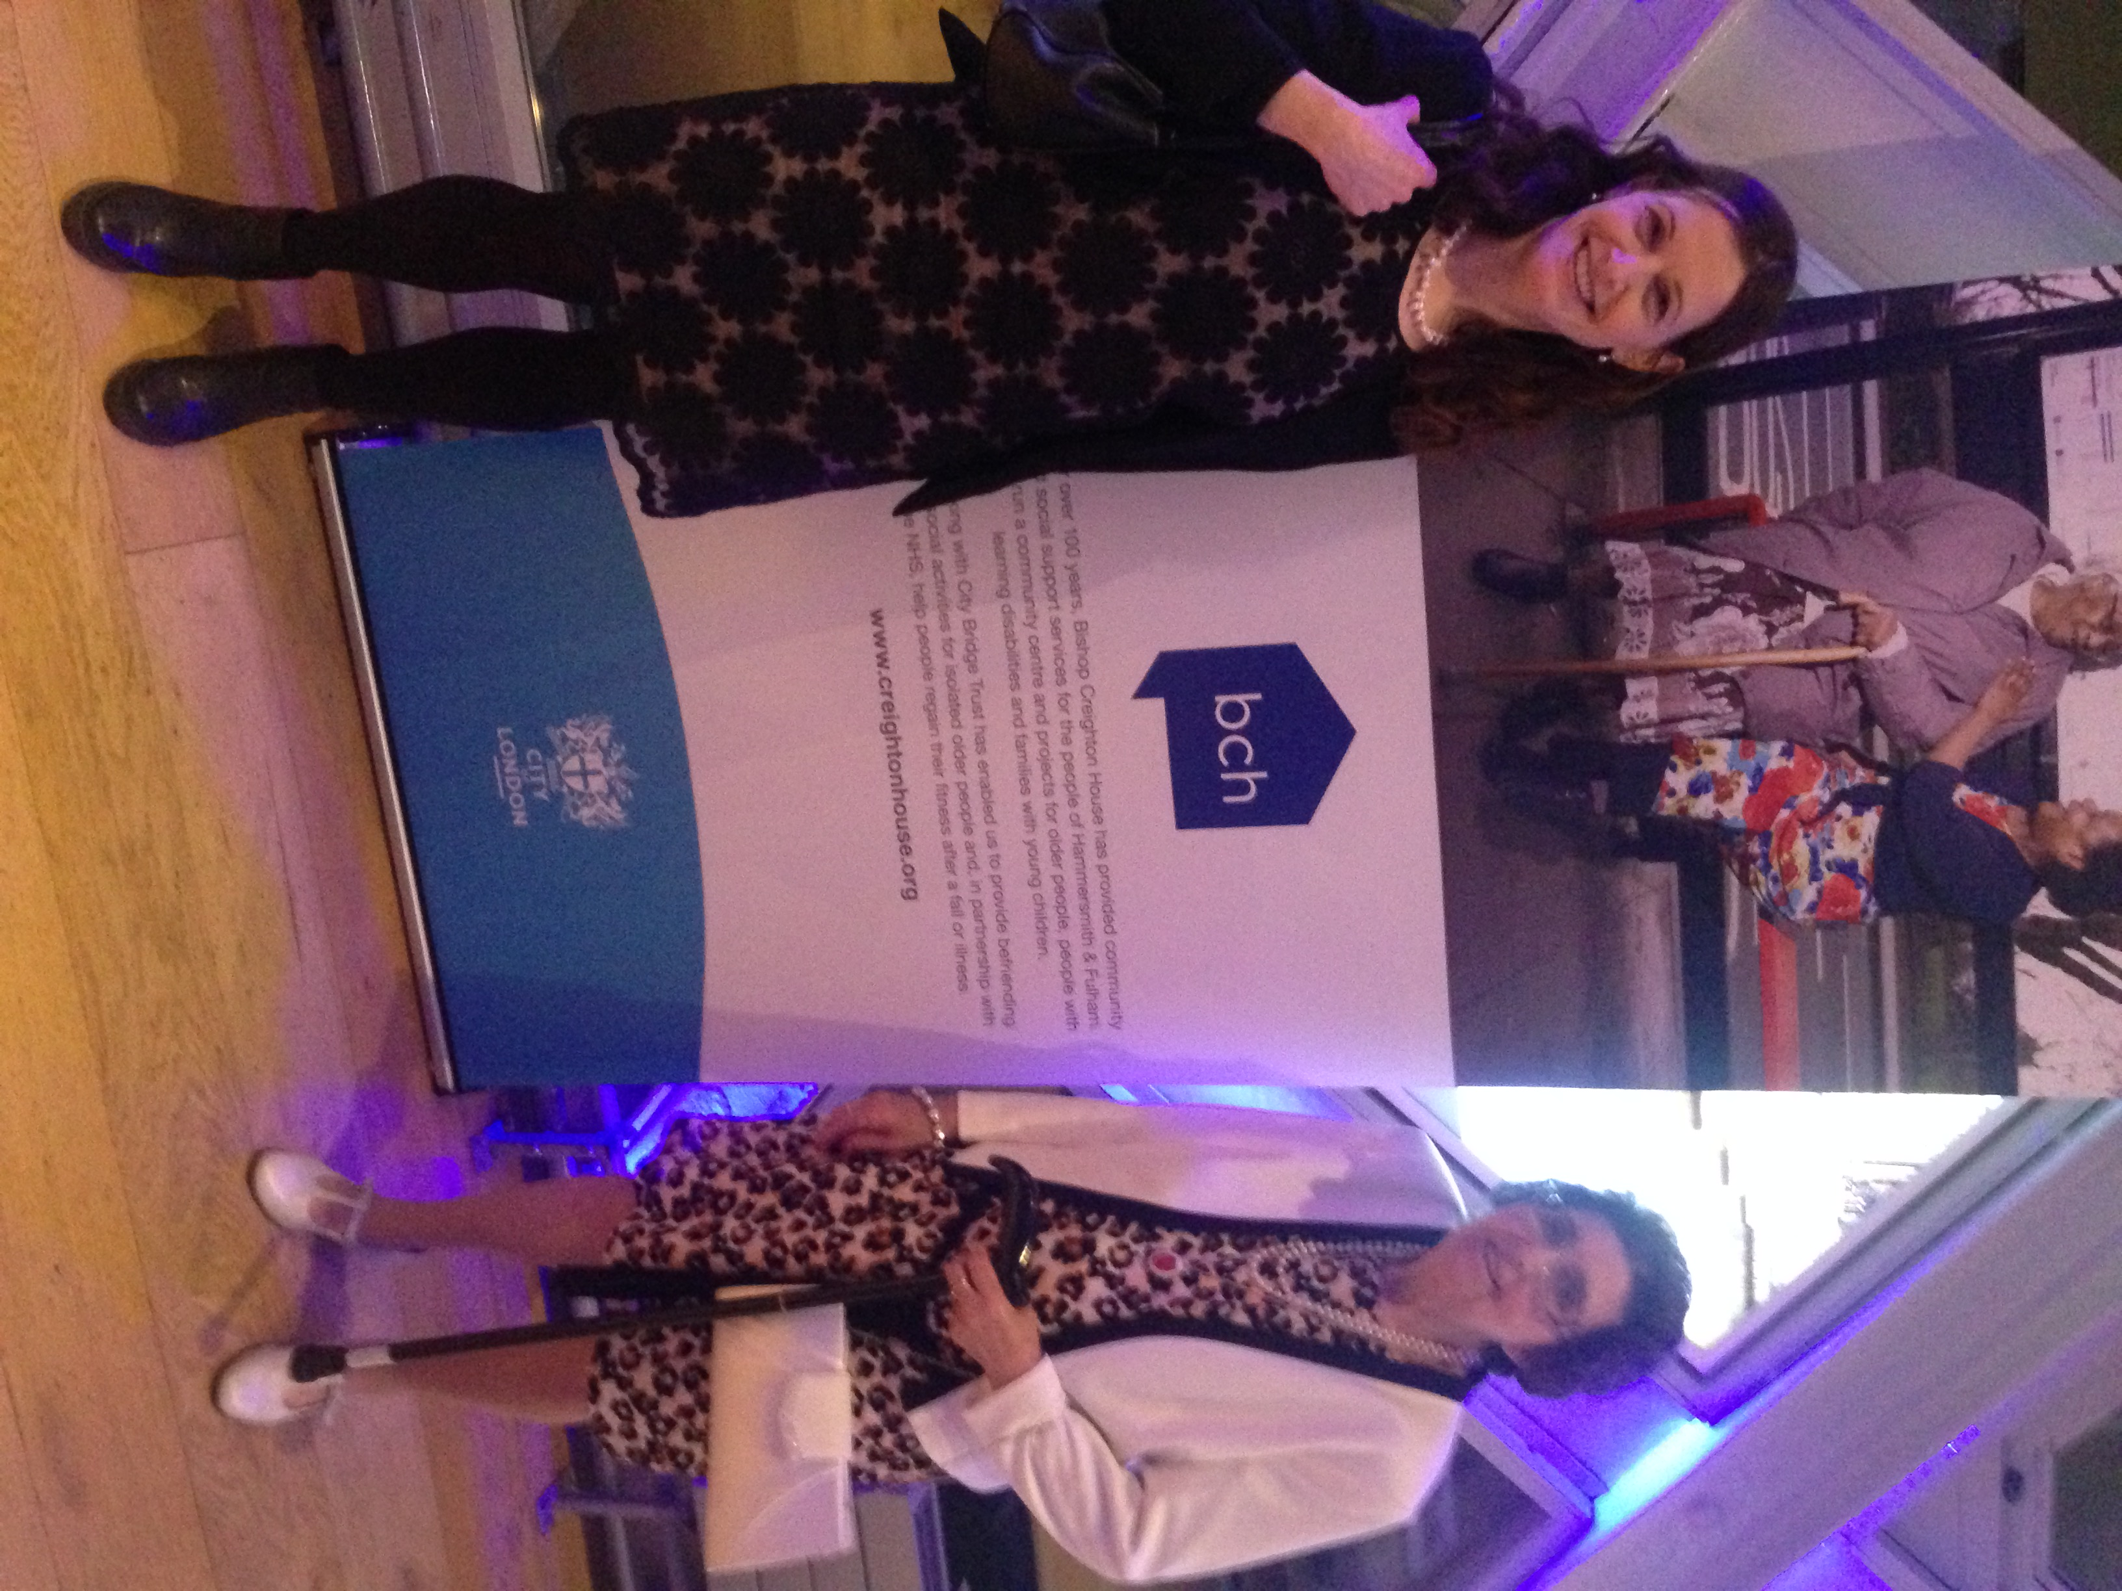
23. How have you found your dealings with the Trust?

Excellent

We have been invited to 2 City Bridge events which were very enjoyable. We were able to bring along a Keep Active client and enjoyed great networking opportunities. We have been very fortunate to have been funded by the Trust. Thank you.

See photo on right of Maureen and Joy at Tower Bridge on 8th March.
24. | Please provide any comments you have about your dealings with the Trust including any problems you may have encountered:  Staff have been most helpful on the telephone, in person and in any correspondence.

25. Please complete the following financial breakdown for the project or activity that was funded by the Trust. This should refer only to the year covered by this report.

Expenditure | £
Capital
New buildings/refurbishment
Office equipment including computers
Vehicle purchase
Furniture or play equipment
Other
Total Capital Costs
Revenue
Salaries of staff | 42262
General running expenses | 8947
Training for staff and volunteers | 609
Consultancy and advice | 707
Other | 74
Total Revenue Costs | 52600
UNSPENT GRANT | -
Total Grant Awarded | 41500

If you have any photographs illustrating the work funded by the Trust, we would be interested to have copies. Please indicate if you give permission for the photographs to be used for our own publicity purposes

To the best of my knowledge, all the information that I have provided in this form is correct.

Signature of person completing form:

Position Held: Manager Keep Active

Date: .......... ................ Photographs can be used: Yes

Concerns over Fraud and Corruption

Should you at any time have concerns of fraud and corruption within your organisation then please raise your concerns with us by using our Whistle Blowing facilities. You may use Audit’s 24 hour answer phone number 0207 332 3663 or email. raiseyourconcern@cityoflondon.gov.uk

Thank you for completing this form. Please could you return it to:
To claim the next instalment of your grant (if applicable)
We need to receive from you:

A payment request form or letter requesting payment signed by your Chair or Treasurer
Your organisation’s income/expenditure budget for the current financial year
Your most recent management accounts

Please enclose these items when you send us your form
 The City Bridge Trust
City of London
PO Box 270
Guildhall
London EC2P 2EJ

 020 7332 3710
 www.citybridgetrust.org.uk

Please note that we do not accept monitoring forms by fax or e-mail
The City Bridge Trust office use only

 |  | Poor | Satis-factory | Good | Very good
1. | Met their objectives: | □ | □ | □ | □
2. | Quality of monitoring statistics: | □ | □ | □ | □
3. | Quality of user feed-back: | □ | □ | □ | □
4. | Impact of the work: | □ | □ | □ | □
5. | Efforts to reduce carbon footprint | □ | □ | □ | □
6. | Trust’s outcomes:  05. Older Londoners,a) More over 75's living healthier and more active lives | □ | □ | □ | □
 | Photographs enclosed: | YES / NO
 | Monitoring visit: | YES / NO
General comments:

Grants Officer initials: Date:

