Homeline
The Creighton Centre
378 Lillie Road
London SW6 7PH T: 020 7385 9689 [option 1]
jradusinovic@creightoncentre.org

Dear Potential Volunteer,

Thank you for your interest in becoming a volunteer befriender with us. Homeline is a volunteer- delivered project at Bishop Creighton House which aims to support isolated and vulnerable older people in the borough of Hammersmith and Fulham.
Please find enclosed an information pack. If you would like to be considered for the role of volunteer befriender please complete the application form and return it to me at jradusinovic@creightoncentre.org or post to me at the address above.

We are looking for people who:
- Live in or near Hammersmith & Fulham, travel regularly through the borough and/or be happy to carry out telephone befriending calls remotely from home
- Able to spare 1-2 hours a week, preferably during working hours (Mon-Fri) and commit to a minimum of a year support.
- Have been resident in the UK for over two years.

Visiting or phoning an older person regularly can make a big difference to their lives and is a very rewarding experience. If you have any questions, or would like to discuss the project in more detail before you complete the form, please feel free to call me on 020 7386 9689 (option 1).
I look forward to receiving your completed form and meeting you soon.
Yours sincerely,

Jelena Radusinovic
Homeline Volunteer Coordinator

Homeline – befriending service
Information for people interested in becoming a volunteer befriender
Introduction to the project
Homeline provides a number of volunteer-delivered befriending services that specialise in meeting the needs of isolated, lonely and vulnerable older people aged 60+, living within the London Borough of Hammersmith and Fulham.
What does a volunteer befriender do?
We have a number of volunteer roles within our Homeline service, which all help isolated older people remain safe and well. List of volunteer opportunities below:
- You could be supporting older people by helping out with our daily telephone befriending service. Our volunteers are allocated a specific day during the week and call a group of older service-users (usually between 5-10) who live alone, providing social contact and checking that they are safe and well.
- You could visit isolated older people in their homes, either providing social companionship and support during a crisis, or becoming a longer-term befriender.
- You could be accompanying older people outdoors by walking with them to assist them to remain independent in the community, and avoid becoming housebound.
- You could help in our busy office with admin.
- Provide simple guidance as a digital inclusion volunteer at our weekly IT class.
- You could help out at our events. You could help to set up, serve food/drinks and chat with service-users at our monthly lunches & afternoon teas.
- You could visit an older person in hospital, during their stay.

Who can be a volunteer with Homeline?
Volunteer befrienders should be willing to make a commitment to be involved with the project for a minimum of one year. You do not need any particular knowledge but you do need to have:
- A positive attitude towards empowering and improving the lives of older people
- Enthusiasm and commitment
- Good communication skills and a good level of spoken English
Important: For practical reasons, there are certain things which we require from volunteers, in order to make sure we can support you and our scheme members fully:
- A commitment of 1-2 hours each week during the day.
- Ability to attend occasional volunteer support meetings and training events.
- To ideally live locally (however, our telephone befriending role works remotely so locations can be further afield).
- You should have been resident in the UK for over two years, so that we can apply for a Digital & Barring Service check on your behalf.

Very occasionally we may decide with you that volunteering with Homeline is not the most suitable opportunity. If this project is not suitable then we can put you in touch with other agencies that need volunteers.
What support do volunteers receive?
- Role specific Induction training
- Regular contact and support and supervision from the Volunteer Coordinator and project staff
- Support meetings with other volunteers & invitations to occasional social events
- Regular newsletters and email updates
- Reimbursement of expenses
- A reference after 3-6 month of volunteering with us (You must have supported a minimum of 1 client)
- An enhanced Disclosure and Barring Service (DBS) check

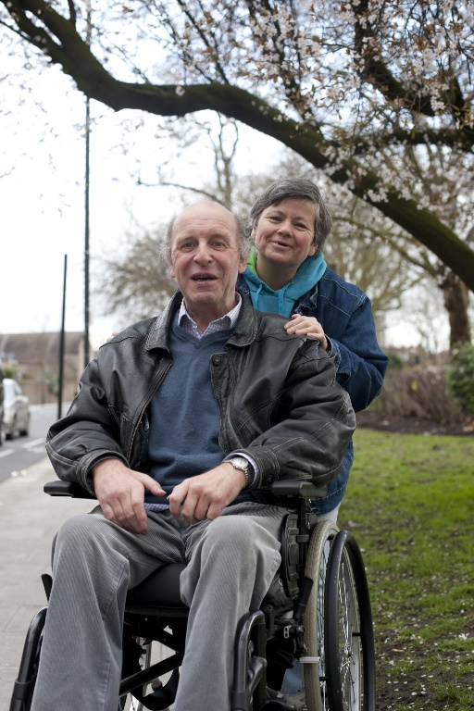
What might a volunteer gain from involvement?
We are a friendly team who really value our volunteers. Our volunteers say they find their involvement rewarding and challenging and a real way of contributing to the local community. Volunteering with us is also an opportunity to gain new skills and experiences. It is a chance to meet new people and hopefully provide a sense of satisfaction from knowing that you are making a positive contribution by giving your support to an isolated older person. Becoming a befriender with Homeline might be useful in gaining paid work or making a career change.
Why is the service needed?
The service is very in demand, especially since the pandemic hit and we have a waiting list of vulnerable older people who are lonely and isolated. They would love the support of a volunteer befriender. Volunteers play a vital part in improving the quality of life of an isolated older person in the community. Without our volunteers many older people in the borough would be lonely and unsupported.
Steps to becoming a volunteer befriender:
- Complete an application form and diversity monitoring form and return them to the Volunteer Coordinator, Jelena Radusinovic, jradusinovic@creightoncentre.org. We will hold your information on our records for the purpose of contacting you. We will not keep your information for longer than needed for that purpose. We will only hold your data for one year after you leave.
- Attend an informal interview (either face to face or via video call) with the Volunteer Coordinator and complete a Digital & Barring Service (DBS) check (paid for by The Creighton Centre), due to the nature of the vulnerable client group being supported. This will check if you have a criminal record – please note if you do have a criminal record you may still be able to be a volunteer, depending on the offence).
- We will contact your two referees.
- Attend induction training and read through policies and procedures.

If all these stages go smoothly then:
- You will be invited to join our Homeline befriending team and choose the opportunity/ies that best suits you: telephone befriending, home visiting befriending, accompanying someone on a regular walk, help in our office or visit someone in hospital.
- There will be an ongoing program of training and regular support meetings you will be invited to.

NB: You may decide at any stage that it is not the right thing for you, or we may suggest that it is not the best volunteering opportunity for you. If this happens then we can help you find other opportunities.

