Keep Active
The Creighton Centre
378 Lillie Road
London SW6 7PH T: 020 7385 9689 [option 6]
hkosa@creightoncentre.org

Dear Potential Volunteer,

Thank you for your interest in becoming a volunteer with us! Keep Active is a volunteer-delivered project run by The Creighton Centre, which aims to provide support to older people who have had a fall, stroke or other illness. We work in partnership with the NHS Community Rehabilitation Service in the borough of Hammersmith and Fulham.
Please find enclosed an information pack. If you would like to be considered for the role of Keep Active volunteer, please complete the application form and return them to me at hkosa@creightoncentre.org or post them to me at the address above.
We are looking for people who:
- Live in or near Hammersmith & Fulham, or travel regularly through the borough
- Are able to spare 1-2 hours a week, preferably during working hours, however we do accept those who are wanting to volunteer after work and on weekends.
- Enjoy older people‘s company and who want to make a difference to someone’s health and wellbeing.

Your visits can make a big difference to someone’s life and volunteering can be a very rewarding experience. If you have any questions, or would like to discuss the project in more detail before you complete the form, please feel free to call me on 020 7386 9689 [option 6].

I look forward to receiving your completed form and meeting you soon.

Hassan Kosa
Keep Active Volunteer Coordinator

Keep Active – 121 exercise/mobility support for older people
Information for people interested in becoming a Keep Active volunteer:
Introduction to the project
Keep Active is a volunteer-delivered project run by The Creighton Centre, which aims to provide support to older people who have had a fall, stroke or other illness. We work in partnership with the NHS Community Rehabilitation Service in the borough of Hammersmith and Fulham.
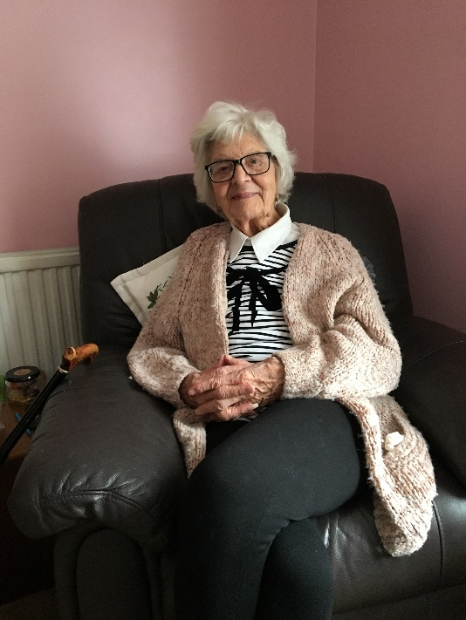
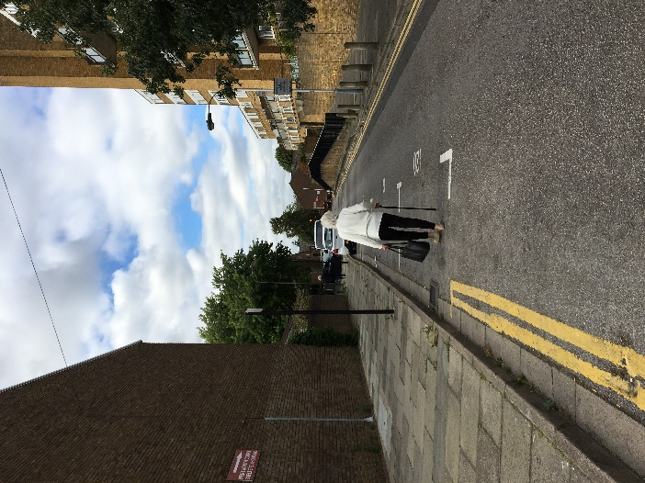
As a Keep Active Volunteer we ask you to visit an older person (the average age is 84) once a week for up to 9 weeks to help them with improving mobility indoors with exercises, or walking outdoors in their community. This service bridges the gap between a period of intense healthcare input for clients and them becoming more independent again! You benefit from training provided by the NHS Community Rehabilitation Team as well as The Creighton Centre.
Volunteer J visited her client M once a week for 9 weeks, working on improving M's outdoor walking stamina. M was able to achieve her goal of walking to the local shop and post office. This allowed M to stay independent and keep doing her shopping!
Who can be a volunteer with Keep Active?
Volunteer should be willing to make a commitment to be involved with the project. You do not need any particular knowledge but you do need to have:
- A positive attitude towards empowering and improving the lives of older people
- Enthusiasm and commitment
- Good communication skills and a good level of spoken English
- Interest in Physiotherapy, Occupational Therapy, Social Care, Rehabilitation Care helps but is not necessary.

Important: For practical reasons, there are certain things which we require from volunteers, in order to make sure we can support you and our scheme members fully:
- A commitment of 1-2 hours each week during the day.
- Ability to attend a training day.
- To ideally live locally and be able to travel within the borough.
- You should have been resident in the UK for over two years, so that we can apply for a Digital & Barring Service check on your behalf.

Very occasionally we may decide with you that volunteering with Homeline is not the most suitable opportunity. If this project is not suitable then we can put you in touch with other agencies that need volunteers.
What support do volunteers receive?
- Induction training with The Creighton Centre and NHS Community Rehab led training .
- Regular contact and support from the Keep Active Coordinator.
- Support meetings with other volunteers & invitations to occasional social events.
- Opportunity to attend occasional training sessions throughout the year such as Heart Start training, Dementia Friends sessions, Diabetes and Parkinson’s training and more.
- Reimbursement of travel expenses
- A reference after 3-6 month of volunteering with us (Must have supported a minimum of 1 client)
- An enhanced Disclosure and Barring Service (DBS) check

What might a volunteer gain from involvement?
We are a friendly team who really value our volunteers. Volunteering with us is also an opportunity to gain new skills and experiences. These include:
- A chance to meet new people who you wouldn’t usually get to meet and interact with.
- A sense of satisfaction from knowing that you are making a positive contribution by giving your support to help an older person recover mobility after a fall or stroke.
- Ability to support people to reach their mobility goals in a short space of time!
- Training from NHS clinical staff and client handovers with them.
- Gaining valuable experience that can support your application to studying, getting paid work, or making a career change (e.g. going on to study medicine, physiotherapy, occupational therapy or social care)
- Becoming a volunteer with Keep Active might be useful in gaining a Further Education Qualification, getting paid work or making a career change.

Becoming a Volunteer with Keep Active

If you would like to become a volunteer, these are the steps you will follow with us
- Complete an application form and diversity monitoring form and return them to the Keep Active Coordinator, Hassan Kosa, hkosa@creightoncentre.org. We will hold your information on our records for the purpose of contacting you. We will not keep your information for longer than needed for that purpose. We will only hold your data for one year after you leave.
- Attend an informal interview (either face to face or via video call) with the Volunteer Coordinator and complete a Digital & Barring Service (DBS) check (paid for by The Creighton Centre), due to the nature of the vulnerable client group being supported. This will check if you have a criminal record – please note if you do have a criminal record you may still be able to be a volunteer, depending on the offence).
- We will contact your two referees.
- Attend Induction training & Community Rehab training – these are during the day and usually start at 0930 and finish at 3.30.

If all these stages go smoothly then..
You will be invited to join our Keep Active team and a handover meeting will be arranged for you and the Keep Active Coordinator to meet a person who has just been discharged from the Community Rehab Service.

You may decide at any stage that it is not the right project for you, or we may suggest that it is not the best volunteering opportunity for you. If this happens then we can help you find other opportunities.

